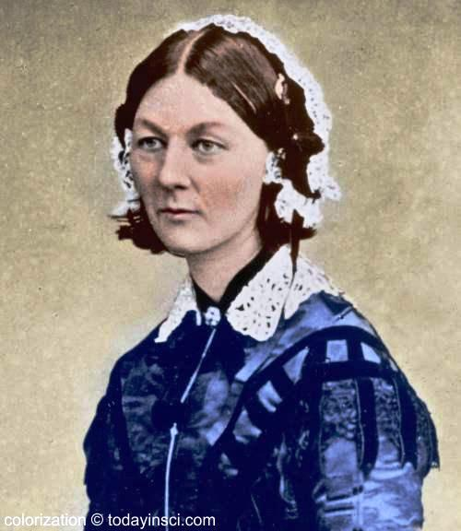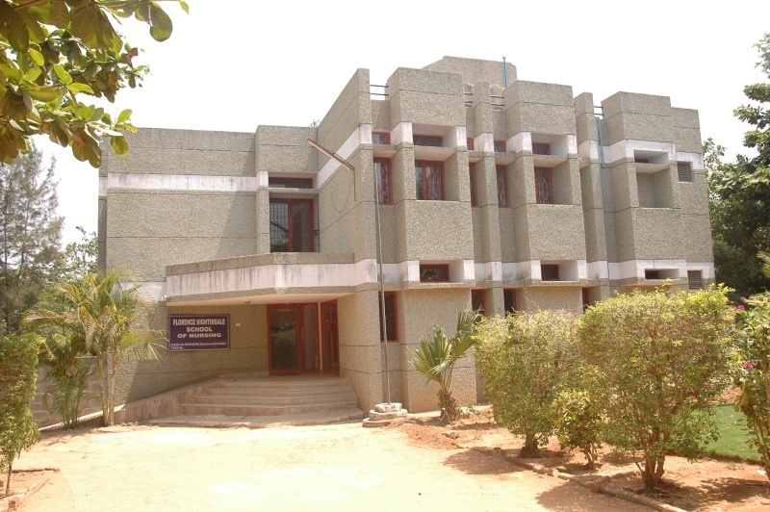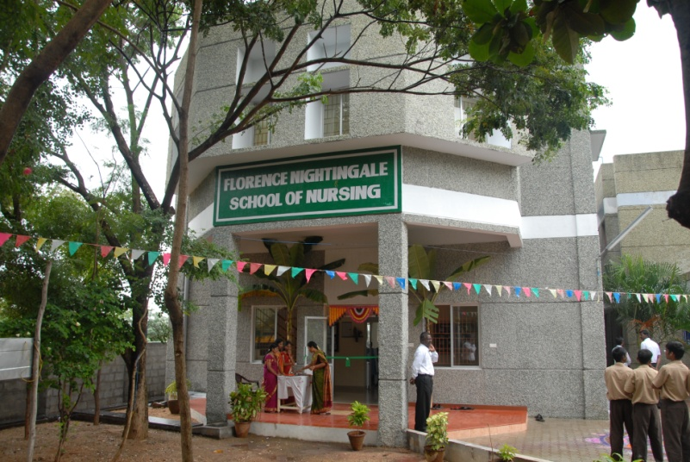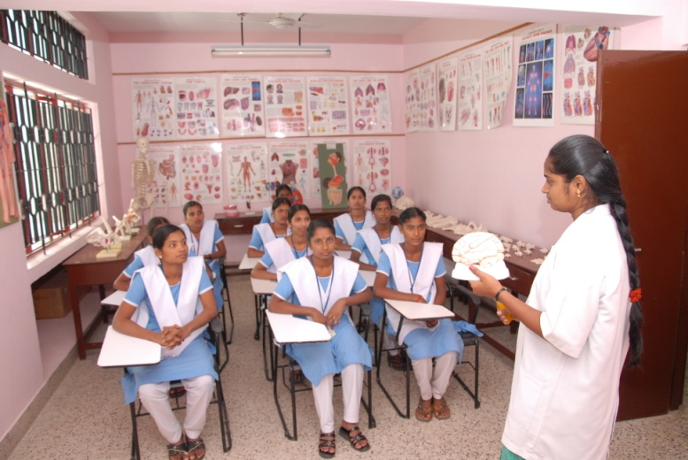

The Florence Nightingale School of Nursing is a unit of Rangammal Memorial Rehabilitation Society. It was established in 2009, with an aim of enhancing the quality of Nursing Education,to imbibe professionalism among nurses and develop an attitude of accepting nursing as a noble profession.

In December 2012 the First batch students successfully completed the course following 6 months of Internship. The 5th batch students classes started in July 2013.

**PHYSICAL INFRASTRUCTURE**

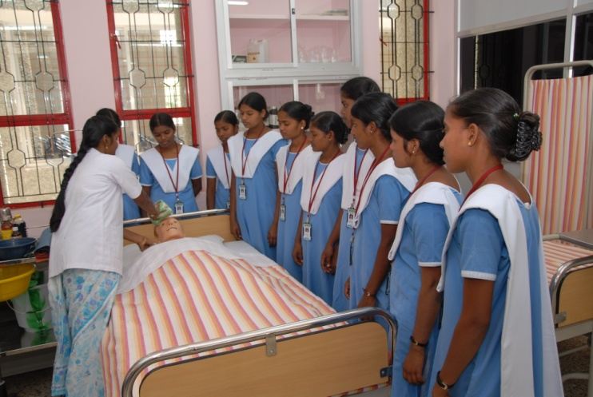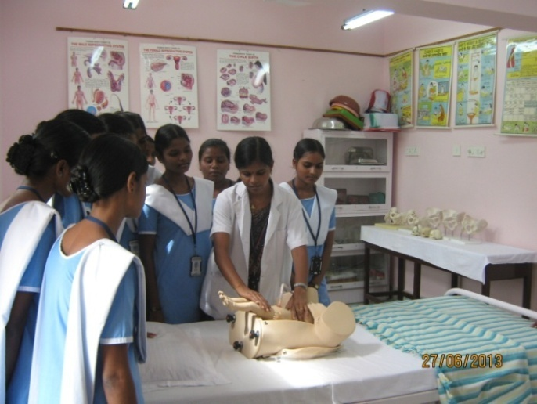

**Fundamental Lab Mother & Child Health Lab**

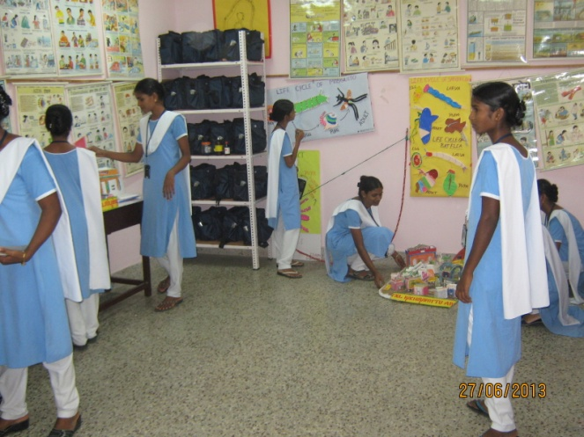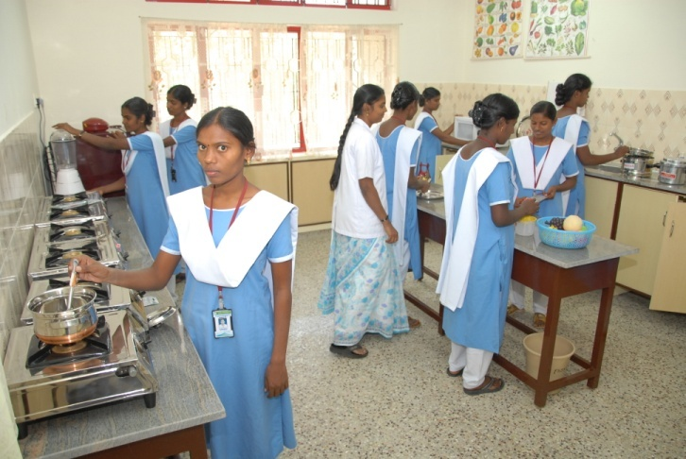

**Community Lab Nutrition Lab**

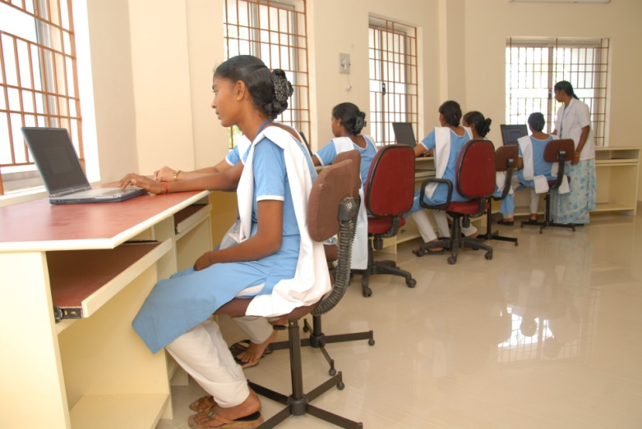

**Computer Lab**

**Library**

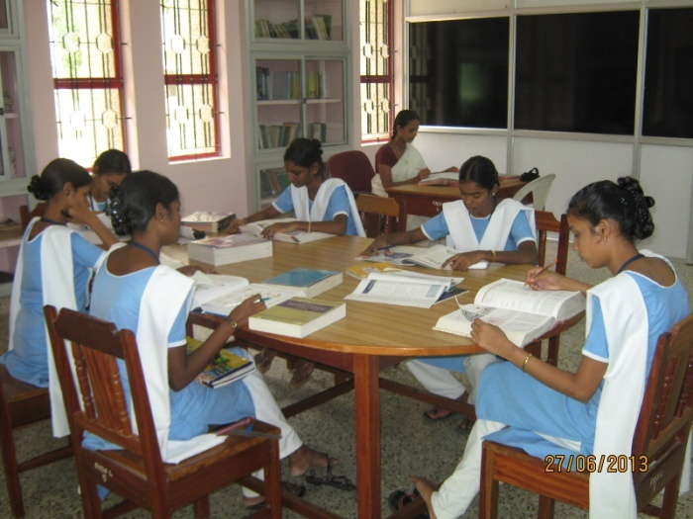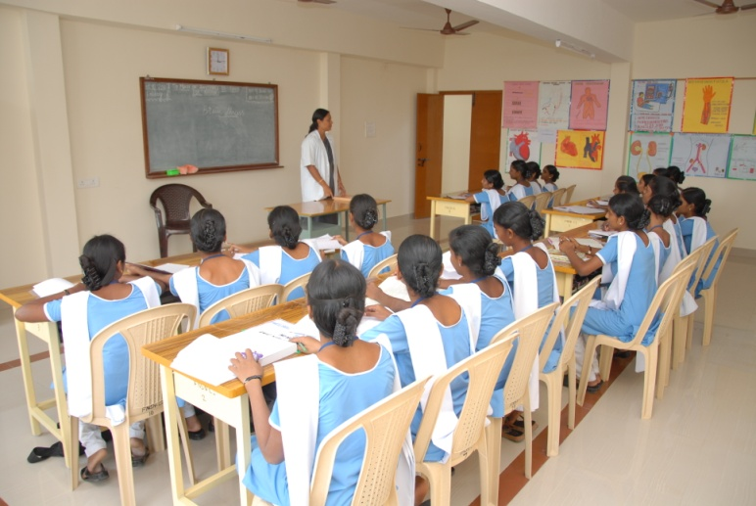

**Classrooms:**

The 4 class rooms are well ventilated and spacious and can each accommodate 40 students. A mobile over head projector is used as and when needed.

**Laboratories:**

We have total 6 labs to teach & train the students on various nursing procedures. The labs are Fundamental, Community, Mother and Child Health, Anatomy and Physiology, Nutrition, & Computer.

All the labs are spacious, well ventilated with beds, manikins and with hand washing facility. The Labs are fully equipped with cupboards and racks& sufficient numbers of articles for the practice of Nursing Procedures by the students.

**Library:**

The library is spacious with many built in racks to keep the books subject-wise. There are about 850 books with various titles in nursing and nursing related subjects. There are also Indian and international nursing journals available. Both Tamil and English daily newspapers are available also.

**HOSTEL & MESS**

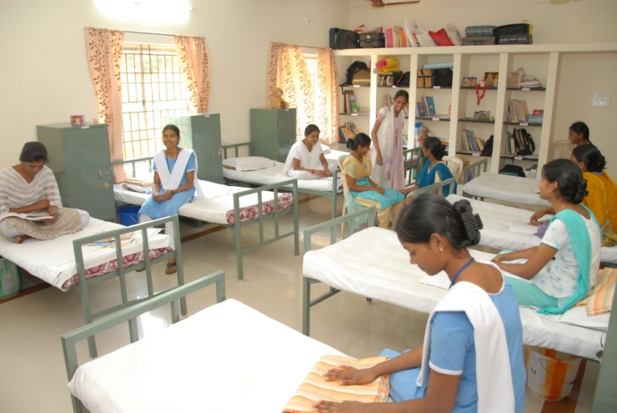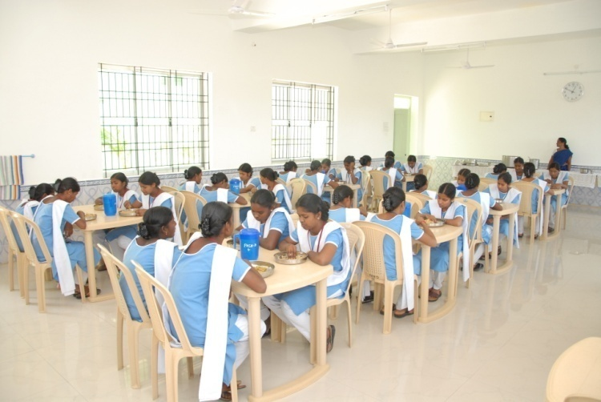

Residential facilities for the students are in a separate building next to the school. Each dormitory accommodates 10 students and are well equipped with Cot, Rack, Chair and book rack for each student. Hostel has adequate Toilet & Bathroom facilities with 24 hours water supply and water heater. Filtered and purified drinking water is available both in the school and the hostel.

**Recreation:** Hostel has facilities for Indoor & Outdoor games. There   is one Television with CD player.

**Dining Hall:** There is a Hygienic Kitchen & dining hall where nutritious diet is provided. A Mess Committee has been formed in which students are the members and at regular intervals the menu is modified as per the feedback of the students. The dining hall can accommodate 70 members at a time

**CLINICAL POSTINGS**

The students are posted in various hospitals for clinical training. They are constantly supervised & guided by the Nursing Tutors.

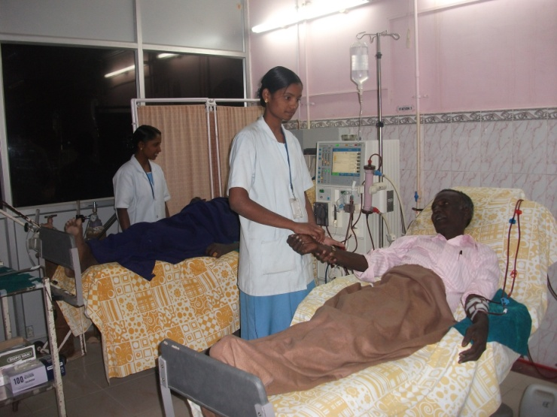

As per the curriculum, students are also posted in the community area where they work along with the village health nurses. They do surveys, home visit and give health education on various health aspects. They also conduct school health programmes.

**ACADEMIC ACHIEVEMENTS**

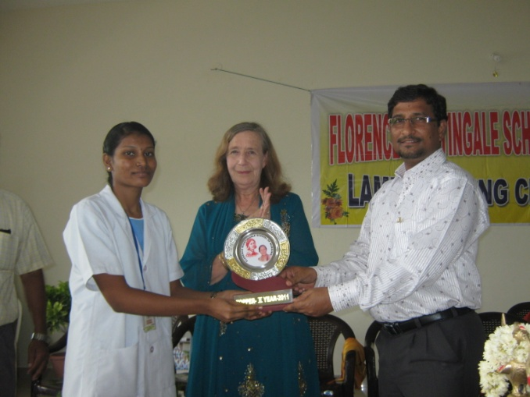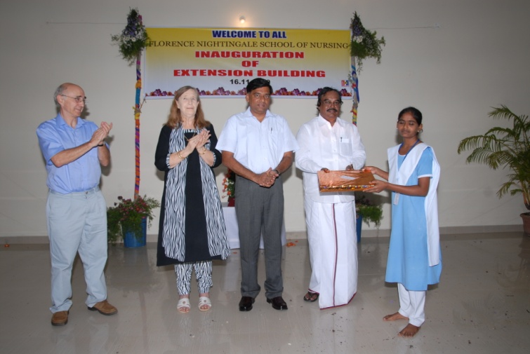

Each year the Academic & the Clinical posting toppers are given prizes. The Exams are conducted by the Government Exam Board. Our First Batch students result is 100%.

**CEREMONIES**

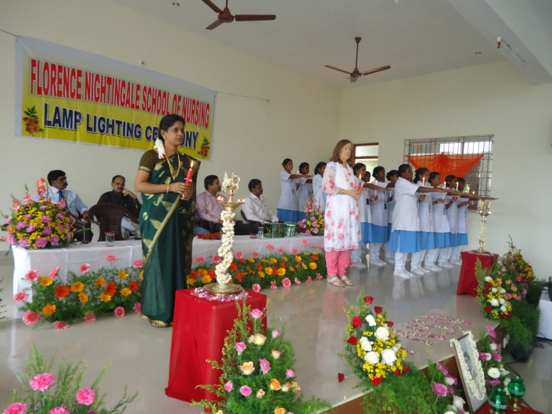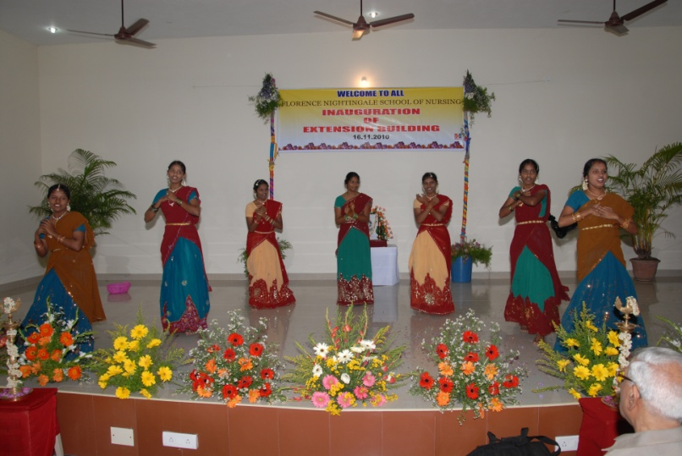

**Lamp Lighting Ceremony** **Cultural**

For the First year students after 3months of admission to the course a Lamp lighting ceremony is conducted after which the students are posted in the clinical areas.

The students have many celebrations like Fresher’s party, Diwali party, Suppose Christmas, Nurses Day, Farewell party etc.

**TOUR**

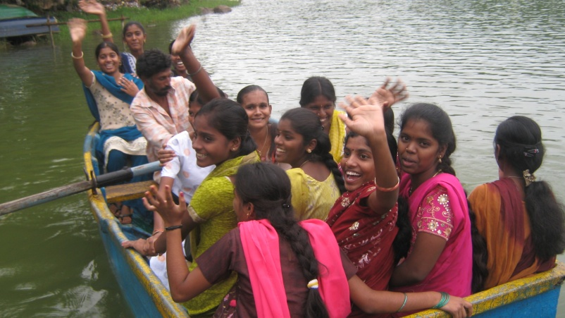

The students were taken for tour to Pondy, Chennai, Yelagiri and Bangalore.

They have attended conferences and workshops.

**FINANCIAL ASSISTANCE**

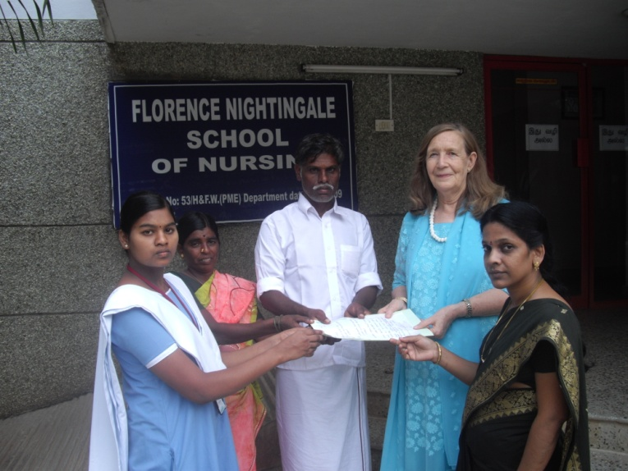

Some students are selected after considering their financial status and academic performance and provided with a Bursary.

Also Government scholarships are sanctioned for certain students from lower socio-economic groups and castes.

**STUDENTS YEARWISE PHOTOS**

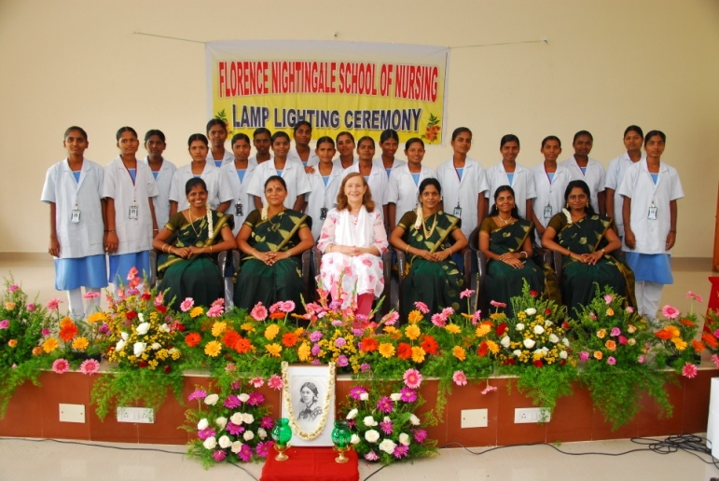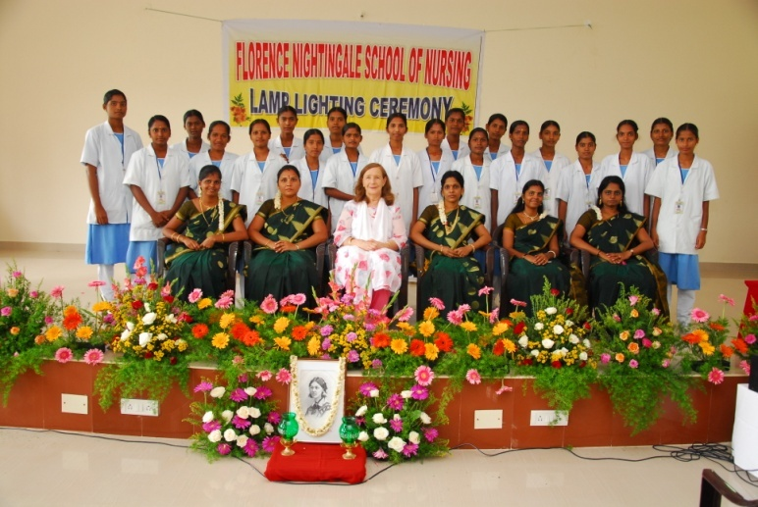

**First Batch Students Second Batch Students**

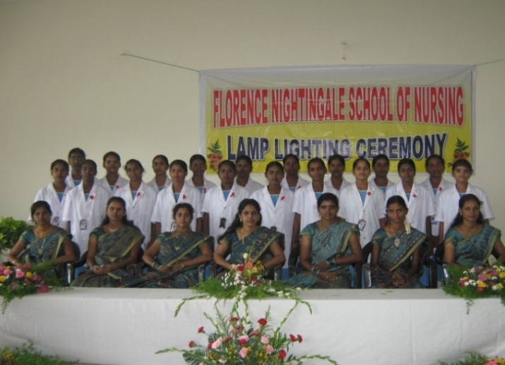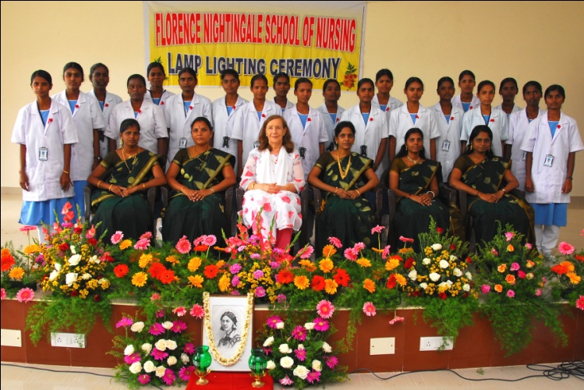

**Third Batch Students Fourth Batch Students**

**VALEDICTORY FUNCTION – FIRST OUTGOING BATCH**

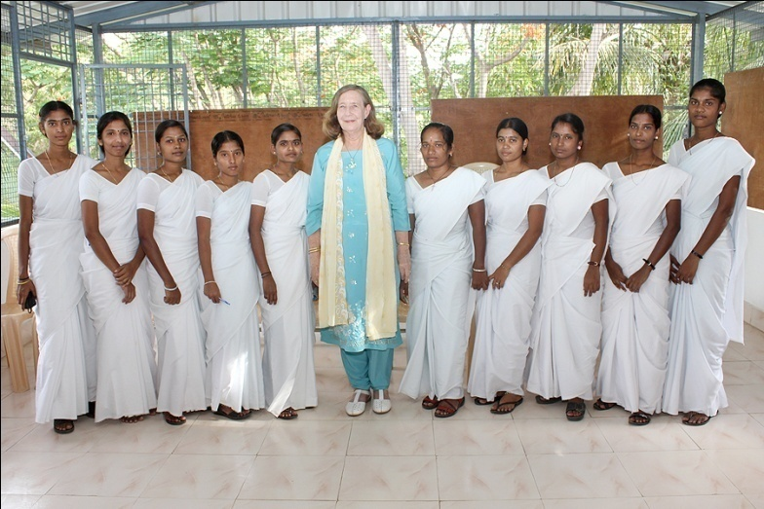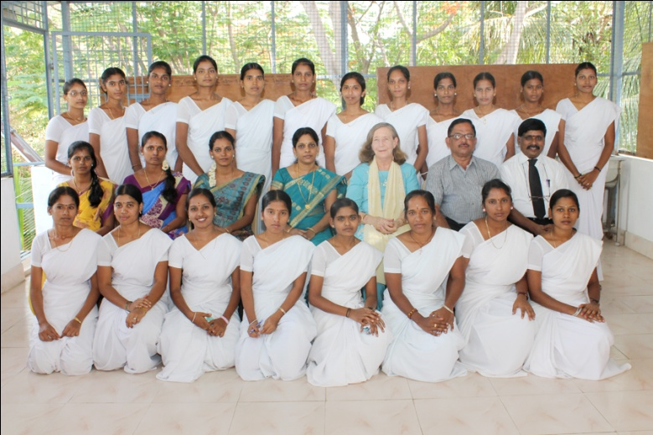

**First Outgoing Batch**  **Students joining as Staff Nurse**

**in RMRH**

The first outgoing batch students arranged a valedictory function in the Hospital on their last working day. Managing Director, General Manager, Principal, Nursing Tutors, Chief Medical Officer and Heads of Department and Ward In-charges attended the ceremony. 10 of them have joined as Staff Nurses in our parent hospital.